(INSERT LOGO OF ORGANIZATION)

You can now save $50 on organic superfoods with (INSERT YOUR ORGANIZATION NAME HERE). **We’re launching a healthy living campaign and would love for you to join us.** It’s a simple “win-win” fundraising program - you SAVE on organic superfoods and a generous donation comes to us!

**Healthy Living Made Easy!**

We’ve partnered with a superfood manufacturer based in Southern California called Purium.

They’ve been making all-natural, non-GMO nutritional supplements for 25 years. What started as a small, family-owned manufacturing business has grown into the largest online farm-to-family superfood store on the internet called **iShopPurium.com**.

**The iShopPurium.com website includes a wide variety of healthy products for:**

* Weight Loss > Cleansing > Athletic Performance
* Energy > Stress Reduction > Mental Clarity
* Sleep > Rejuvenation > Healthy Aging

All of the products are pure: no artificial colors, no artificial flavors, no artificial sweeteners, no binders, no fillers, no hormones, no pesticides, and no genetically-modified ingredients. Plus, every product has a **60-day, money back guarantee**.

**You Save $50 on your first order!**

We have a **$50 Gift Card** for you to use on your first iShopPurium.com order. Just purchase $75 of products (or more) and you save $50 with our code. Plus, you’ll **save up to 25%** on all future orders!

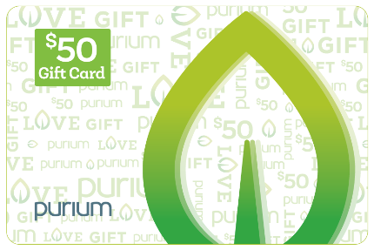 **Use the Gift Card Code: (insert organization’s Gift Card Code)**

**We Earn 20% FOR LIFE**

Purium **donates** **20%** on everything you spend, for as long as you are a Customer. So, this is the fundraiser that can keep on giving to your health **and** our community! You can **share our code** with anyone you know. The more **you** share, the more **we** receive. Anyone you share our code with will also save $50 on their first order and up to 25% on all future orders. Purium will make a 20% donation on these purchases as well. The more you share, the more is donated!

**What You Do:**

Go **to iShopPurium.com** and order any products you’d like.

Just enter our Gift Card Code when you are checking out and you’ll save $50. That’s it!

And 20% from all future purchases will be donated back to us.

Then, please share our Gift Card Code with others if you’d like.

This is a health initiative that everyone can feel good about!