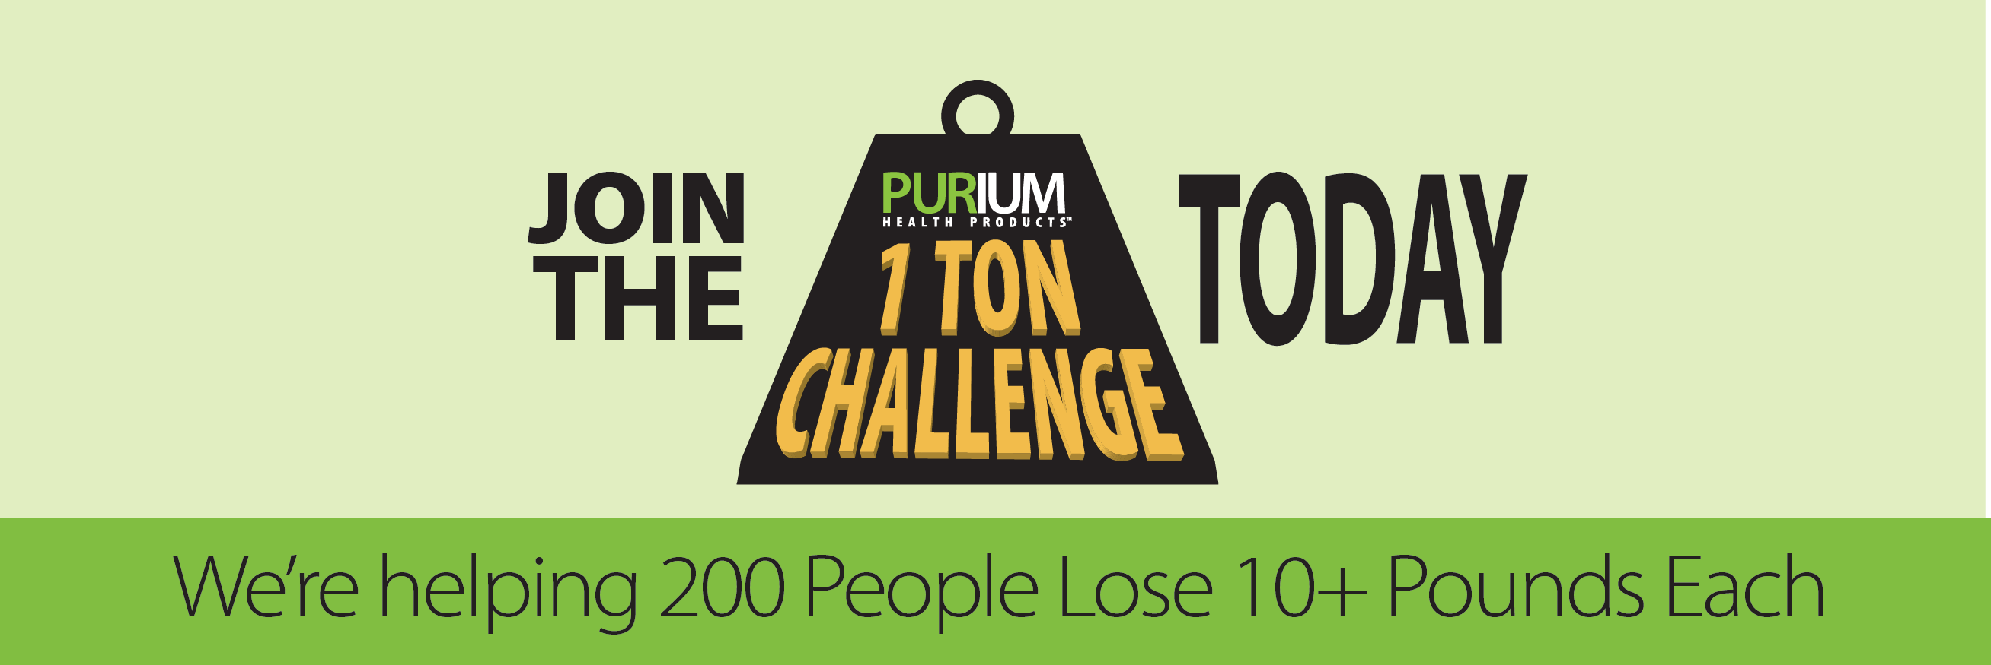

**Subject: Follow-Up to our call – 1 Ton Challenge Info**

Thank you for your time on the phone. Please review this information and I will be calling you in the next 48-72 hours.

As we discussed, we are looking for select motivated (salons) in the (Long Beach) area who want to **earn $10,000 or more** running a really fun and very effective **weight loss challenge** for their clients.

**It’s called the 1 TON CHALLENGE.**

The number one New Year’s resolution is “losing weight” … and we have a simple, proven program that helps people **lose 10 pounds in just 10 days**!

The timing is perfect since **hundreds of people** will pass through your salon in the next 30 to 60 days who will be interested in starting a New Year’s Resolution to lose weight. This is your chance to **earn thousands of dollars** from the same base of clients already walking in your door. Plus, you will be making a positive impact on the health of your community.

**Here’s what you get:**

* A 10-Day Transformation so you can participate in the Challenge

(and lose 10 pounds yourself!)

* 2 posters and 100 flyers to promote your Challenge
* An UNLIMITED amount of $50 Gift Cards to offer to your clients

(you start with 100 Gift Cards and once they are all redeemed we will send you 100 more absolutely FREE … and we will continue to do so for 1 year)

* Website & Text Message Platform to help present the Transformation
* My help … I get paid to help and your clients you succeed

The initial 100 Gift Cards alone are worth $5000 …

but we are only charging $499 to sponsor a 1 Ton Challenge.

**Here’s what you do:**

* Hang up the posters
* Pass out the flyers and $50 Gift Cards
* Your clients pay $230 for the 10-Day Program
* The average person loses 11 pounds and 8 inches in just 10 days

**Here’s what you earn:**

* You earn $50 per client
* Complete a 1 Ton Challenge (200 Transformations) and **you earn $10,000**!
* Plus, we’re giving away **an extra $2,000** for the first salon to hit the mark!

**Watch these short videos on the 10-Day Transformation to learn more:**

**How it works:** [**https://vimeo.com/103380302**](https://vimeo.com/103380302)

**Success Stories:** [**https://vimeo.com/103379493**](https://vimeo.com/103379493)

**Magazines like Harper’s Bazaar and Muscle and Fitness are talking about us:**

**http://www.harpersbazaar.com/beauty/diet-fitness/a11550/i-tried-the-cleanse-everyone-is-talking-about/**

[**http://www.muscleandfitness.com/muscle-fitness-hers/hers-workouts/how-look-leaner-and-fitter-less-3-days?page=2**](http://www.muscleandfitness.com/muscle-fitness-hers/hers-workouts/how-look-leaner-and-fitter-less-3-days?page=2)

I look forward to reconnecting so we can get a 1 Ton Challenge going for you!