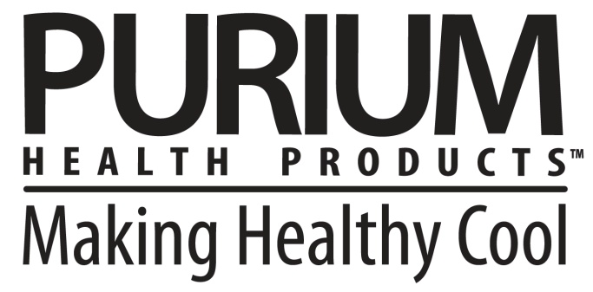

**PLEASE READ PRIOR TO CREATING YOUR OWN ADVERTISING MATERIAL**

In an effort to empower Independent Distributors to create their own marketing material, Purium provides the ready use of several commonly requested graphics. Before creating and using your own materials to promote Purium, please note the following criteria:

* All Member/Professional-created material must first be submitted to the Corporate office via [compliance@puriumcorp.com](mailto:compliance@puriumcorp.com) for approval prior to distribution.
* All websites, Facebook accounts, etc may not include the name Purium Health Products, Power Shake, 10-Day Transformation or any of our brand names and trademarks in the URL in a way that may confuse one into thinking it is run by the corporate office. It must be clear that the operator of the site is an independent distributor.
* Members and Professionals may not describe themselves in any manner that would lead a customer or potential customer to believe that he/she is communicating with the corporate offices of Purium Health Products and not an Independent Distributor.
* Members and Professionals may not reproduce – for sale or personal use – any recording of Company produced audio or video presentations without explicit approval.
* Members and Professionals are liable for damages resulting from unauthorized use of Purium copyrights, trademarks, and materials.
* Violation of any of the rules in the Policies and Procedures by a Member or Professional will be grounds for termination.

**Please see the Policies and Procedures document in your Back Office for more details.   
Please email any questions to** [**compliance@puriumcorp.com**](mailto:compliance@puriumcorp.com) **and allow 24 business hours for response.**